**"Implement a class in CPP representing bank account containing appropriate data members and functions.**

**Q.1 BNK/01**

**The class should have following data members : Customer Name, Account Number, Type of Account (Savings/Current etc), Account**

**Balance.**

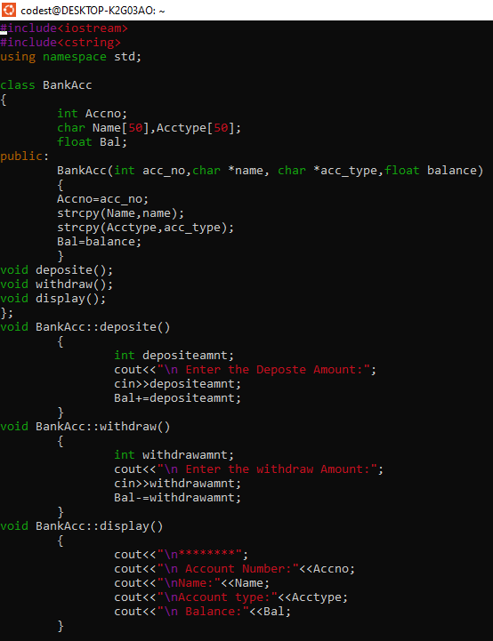

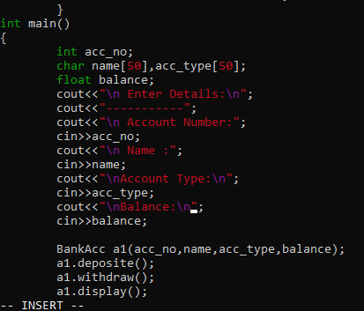

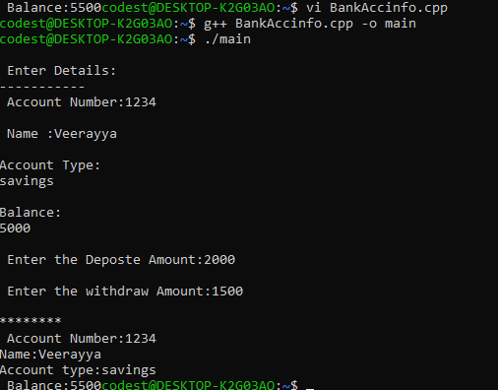

02)

The class should allow basic operations like creating a new account, deposit an amount, withdraw money after checking the balance, display account details.

